Problem 1

A database for a banking system is used to control withdrawal, deposit and loan transactions with customers, banks which use this system has many branches, each branch has a unique name, address (unique) and phone .The system stores information about customers as cust_id (unique), name, address, and phones. each customer has one credit identified by credit_no (unique), amount and last_transaction_date(day,month,hour),transaction_time. Customer can make any type of transactions(withdrawal,deposit) from any branch of the bank .the system record trans_no, trans_type, trans_date, trans_amount .system record the branch name where the transaction occurred.

Draw an ER diagram. Estimate any missing assumptions

Trans. no
Trans_type
Trans_date
Transtime
Trans_amount
Phone
Add.
Name
Phone
Credit.no
last_transaction_date
Make
Deal
Has
Make
Customer
Transaction
Branch
Credit
1
1
M
1
1
N
M

Add.
Branch _name

M

Amount

Customer _id

s

Problem 2

Design an ER diagram for a license issuing process of vehicles. The data requirements are as follows:
- The country is divided into departments (Cairo, Giza, Alex…etc). Each department is described by a code (unique), name (unique), and several service locations (e.g., for Cairo department, there are: Heliopolis, Nasr City, etc.).

- Each vehicle is described by a vehicle no, model(ex. Hyundai accent, Hyundai matrix ,fiat 128,fiat punto) , type(private, limousine, taxi,…etc), color, motor capacity, number of seats, manufacturing year, license issue date, license expiry date, owner, tax rate, and a set of fins. The owner, type and tax rate information are mandatory for each vehicle. Each vehicle model is identified by a code (unique), name (unique) and tax category. Each tax category has a specific tax rate and category_id. The tax category has one or more vehicle models.

- Each vehicle fin is described by a number (unique), type, date, and vehicle no. Each fin type has a specific value and description.
- Each owner is described by id (unique), name, type (individual, organization, government, etc.), address, and set of phone numbers.

Type-of
Belong-to
Type-of
Owned-by
Category of
Type
value
Code
Name
Service_loc
License_issue_date
Manuf_year
Color
Num_of_seats
Name
Code
Tax_rate
Name
ID
Address
phone
type
License_expire_date
Department
Fine_type
Vehicle_model
Tax_category
Vehicle_owner
1
M
M
1
M
1
M
1
M
1
Vehicle

Vehicle_fine

Num
date
vehicle no
Category id
Type
Has a
M_capacity

1
M

- A company is organized into departments. Each department has a unique name, a unique number, and a particular employee who manages the department. A department may have several locations.
- A department may control a number of projects, each of which has a unique name, a unique number, and a single location. A project must controlled by department.
- We store employee’s name, social security number, address, salary, gender and birth date. An employee must be assigned to one department and must work on one or more projects, which are not necessarily controlled by the same department. We keep track of the number of hours per week that an employee works on each project. We also keep track of the direct supervisor of each employee.
- We want to keep track of the dependents of each employee for insurance purposes. We keep each dependent’s first name, gender, birth date and relationship to that employee.
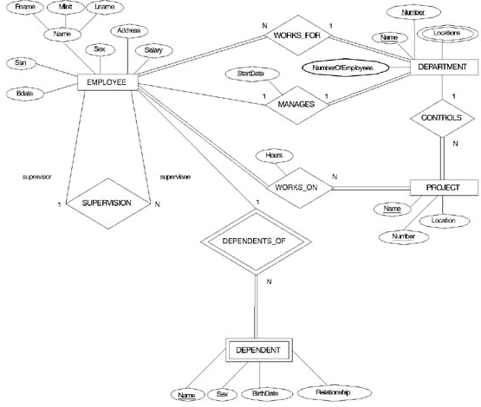

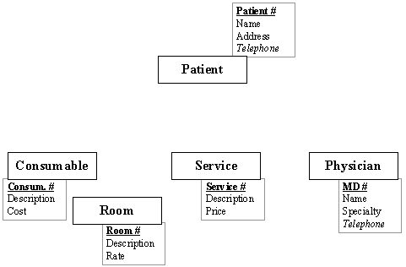
- (MVH) is a small 100-bed community hospital that is trying to deliver high-quality health care while controlling costs within a service area that includes a section of central Colorado. The population of the service area is growing rapidly (at greater than 8% per year) as more people move to the area, and MVH is attempting to upgrade its information infrastructure to handle a greater patient load without a greater increase in costs. The hospital is expecting to increase by 50 beds in the next two years, and has placed money in its strategic investments fund to support the development of new information systems to support its internal medicine and surgical care divisions. Medicine accounts for 60% of the hospital's patient load and the Surgery service accounts for most of the rest.

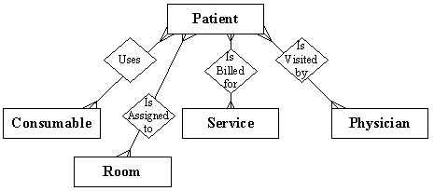

Airlines ERD Case Solution

Major airlines companies that provide passenger services in Taiwan are: UniAir, TransAsia Airways, Far Eastern Transport, Great China Airlines etc.
Taiwan’s Federal Aviation Administration (TFAA) keeps a database with lots of information on all airlines.
This information is made accessible to all airlines in Taiwan with the intention of helping the companies assess their competitive position in the domestic market. The information kept consists of:
1. Each airline has an identification number, name and address, name of the contact
person and telephone numbers.
2. Each employee works in Airline Company has an employee identification number, name, address, birthday recorded as (day, month, year), sex, position with the company, and qualifications.
3. Each airline owns different aircraft models . For each aircraft an aircraft identification number, capacity, and model is recorded.
4. The aircrafts are assigned to different routes. With some information as number of passengers, departure time, arrival time and the time that aircraft spent in the flight .

Each route has a route identification number, origin, destination, classification
(Into domestic or international route), distance of the route, and price charged per
Passenger.

5. Each aircraft has its own crew (major pilot, assistant pilot and two hostesses) , the aircraft crew not stored as employee.

6. Each airline keeps information about their buy/sell transactions (for example
selling an airplane ticket is a sell transaction, paying for maintenance is a buy
transaction). Each transaction has a transaction identification number, date,
description, and amount of money paid/received.
Draw an E-R diagram for the database presented above.
Belong-to
Owned-by
sex
Num

trans_id
Trans_type
description
Num
Phone
Contact_person
Name
address
model
Num
hostessA
Major-pilot
Num
Origin
distance
price
classification
Name
position
address
Qualification
amount
date
capacity
destination
assess-pilot

hostessB

Employed-at
Fly_time
Passengrs_num
Has a
depar_time
Arrival_time
Assign-to
birthdate
year
day
month
Airline
Transaction
Aircraft
Crew
Route
1
M
M
1
1
M
M
M
1
1
Employee

